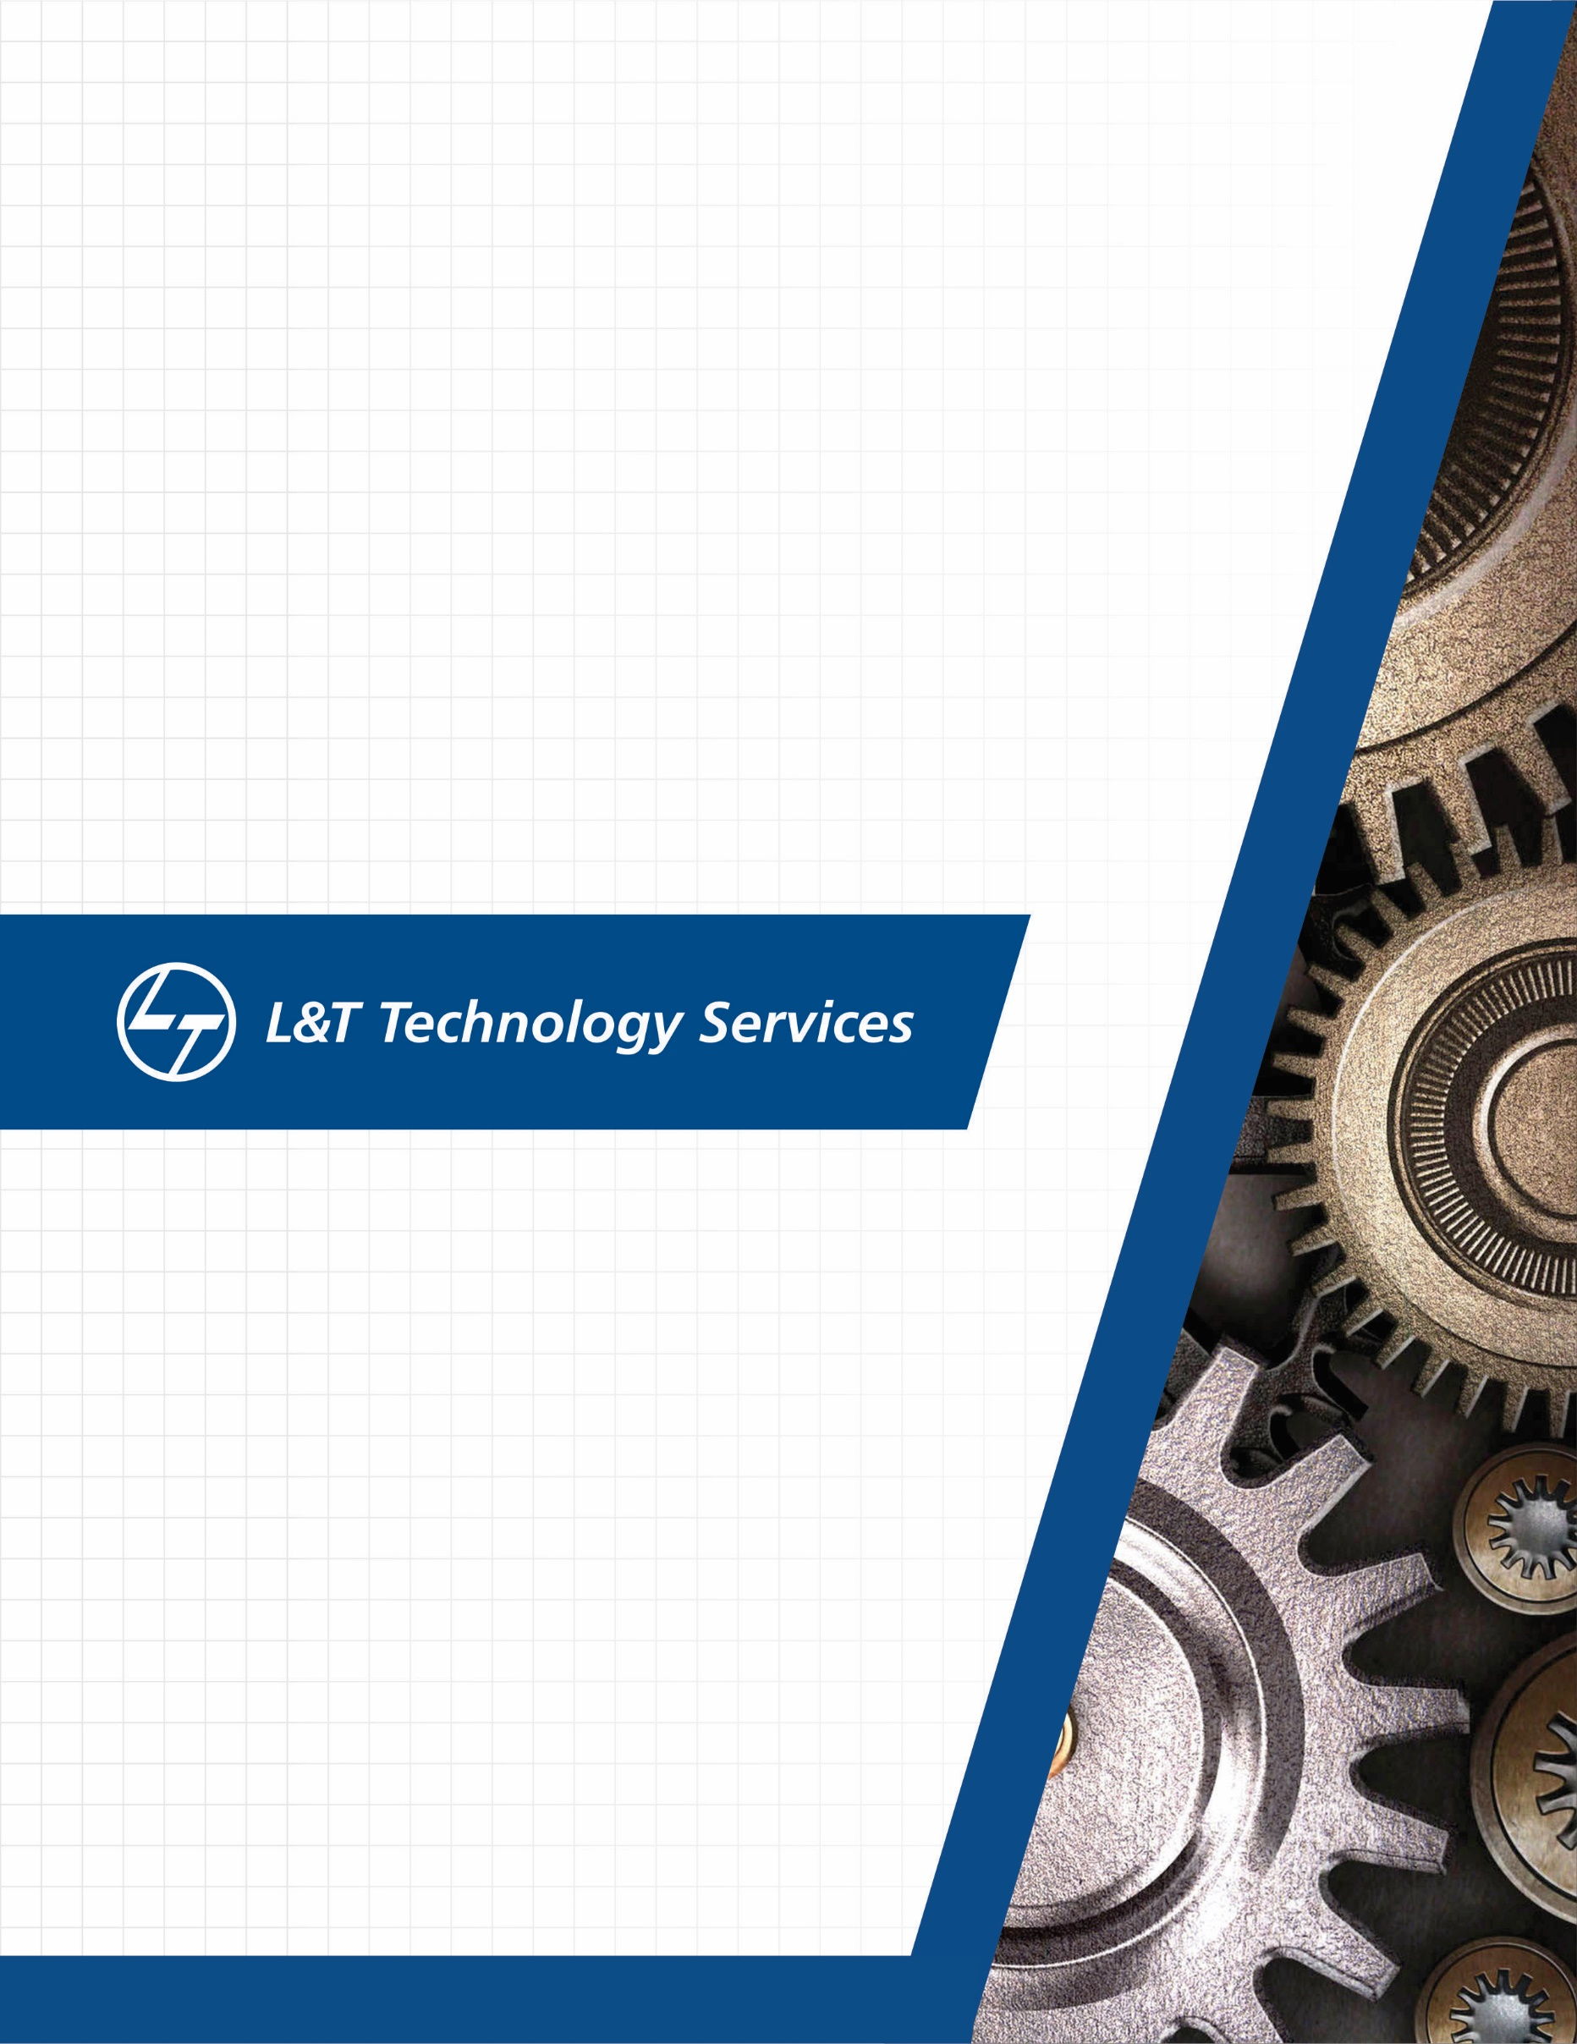./

MBSE-REPORT



|  |  |  |  |  |  |
| --- | --- | --- | --- | --- | --- |
| **Ver. Rel. No.** | **Release Date** | **Prepared. By** | **Reviewed By** | **To be Approved** | **Remarks/Revision Details** |
| 1 | 21-12-2020 | Pranav V Bharadhwaj |  |  |  |
|  |  |  |  |  |  |
|  |  |  |  |  |  |
|  |  |  |  |  |  |
|  |  |  |  |  |  |

**Details**

# TABLE OF CONTENTS

Contents

TABLE OF CONTENTS 3

Contents 3

ACTIVITY-2 5

**Subsystems** 5

**Powertrain** 5

**Chassis** 5

**Electronics** 5

**Steering** 6

**Suspension** 6

**Control Systems** 6

**Function** 7

**Power-assisted brakes** 7

**Disc brake** 9

**Drum brake** 10

ACTIVITY-2 13

**Actuators** 13

**Types of sensors** 13

ACTIVITY-3 15

**How BMC is applicable to transport** 15

**Application of ECU’s** 15

ACTIVITY-4 17

**Application of MBD in vehicle** 17

**LIST OF FIGURES**

Figure 1: POWER BRAKING SYSTEM 7

Figure 2: Brake off - both sides of the diaphragm are under vacuum 8

Figure 3: Applying the brake lets air in behind the diaphragm, forcing it against the cylinder. 9

Figure 4: DISC BRAKE 9

Figure 5: SINGLE PISTON PAIR 10

Figure 6: DRUM BRAKE 11

Figure 7: DRUM 11

# ACTIVITY-2

## **Subsystems**

* These include powertrain, chassis, electronics, steering, suspension, control systems, and composites. All of the subsystems are important and dependent on each other.
* Designers typically do not choose just one subsystem to work on, but divide their time based on the priority of the subsystem.

## **Powertrain**

* The powertrain subsystem includes everything that is responsible for transmitting its power to the wheels.
* The first component after the engine is the continuously variable transmission (CVT). The CVT provides a dual purpose in our vehicle. First, it acts as an automatic transmission, allowing adjustment to the final drive ratio
* Italso functions as a clutch between the engine and transmission as its pulleys allow for slip at engine idle. After the CVT, power is transferred into a standard transmission, allowing gear ratios in forward and reverse.
* This is helpful for different parts of the competition or when our motion is hindered by an obstacle. Power is then transmitted to the differential, whose job is to directly power the left and right wheels while allowing them to rotate at different velocities around turns.
* Out of the differential, power goes to the rear wheels via a set of constant velocity (CV) joints and half shaft axles.

## **Chassis**

* Thegroup which develops the chassis subsystem work alongside all the other subsystems to ensure that the strength and geometry of the chassis satisfies the requirements set by the Society of Automotive Engineers (SAE) for the competition, along with the design criteria established by the team. Fabrication of the frame begins during winter break.

## **Electronics**

* Electronics are implemented in the design, testing, and fabrication of the vehicle in many ways. Data acquisition through an assortment of sensors gives designers useful information about a variety of characteristics, including various angular velocities and accelerations, suspension travel, and component temperatures.
* This data is then utilized in the design process to create/modify parts or to verify and reinforce computer-simulated results through real-world testing.
* A driver-interface system has been used in the past to allow the driver to view live information about the vehicle through an LCD mounted in front of the steering wheel. In addition, all of the required lighting, alarms, and kill-switches are covered under this subsystem.

## **Steering**

* The steering subsystem is responsible for providing the operator with maximum directional control over the vehicle via the steering wheel. The steering wheel rotational input is transferred down the steering column to the steering rack.
* The purpose of the steering rack is to translate the rotational motion of the steering column into lateral, linear motion by means of a rack and pinion gear set. Attached on each side of the rack are tie rods, which transfer the lateral motion of the rack to the steering arms - one mounted at each front wheel.
* When the tie rods push / pull on the steering arms, there is a change in the direction of the wheel. The combined ratio of the gear set and steering arms provide the final steering ratio of the vehicle. In the end, if the driver turns the steering wheel clockwise, the car will turn right and when turned counterclockwise, the car will turn left.

## **Suspension**

* The Designing of the suspension requires a combination of numerical analysis, computer simulation, and real world testing. All other subsystems are vastly affected by suspension geometry, tire choice, and shock setting.
* Because nearly all suspension components are fabricated by the team, members will learn about the design, fabrication, data collection, and analysis techniques involved in the performance and handling of the vehicle to a considerable degree.

## **Control Systems**

* The control systems of the vehicle encompasses all driver-vehicle interfaces. Cockpit ergonomics are researched to ensure that the car is suitable for commuter conditions.
* Transmission and steering controls are laid out to ensure that the driver can quickly and comfortably control the vehicle without excessive effort.
* This group is also tasked with designing the brake system so that the car successfully locks all four wheels, a requirement for technical inspection. Any electronics on the vehicle are also included in the control systems category.

## **Function**

* The powertrain provides power to the car. Power is made by the engine, then transferred to the driveshaft through the transmission. The driveshaft, in a rear wheel drive car, turns the gears in the rear, which in turn turns the axles and finally, the wheels. The rear and the axles are also part of the drivetrain.
* Most cars now also have a load-sensitive pressure-limiting valve. It closes when heavy braking raises hydraulic pressure to a level that might cause the rear brakes to lock, and prevents any further movement of fluid to them.
* Advanced cars may even have complex anti-lock systems that sense in various ways how the car is decelerating and whether any wheels are locking.
* Such systems apply and release the brakes in rapid succession to stop them locking.

## **Power-assisted brakes**

* Many cars also have power assistance to reduce the effort needed to apply the brakes.

Usually the source of power is the pressure difference between the partial vacuum in the inlet manifold and the outside air.

* The servo unit that provides the assistance has a pipe connection to the inlet manifold.

[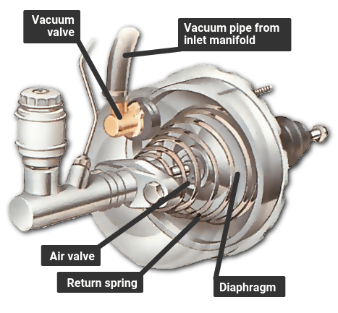](https://www.howacarworks.com/illustrations/servo-assisted-braking)

Figure 1: POWER BRAKING SYSTEM

* A direct-acting servo is fitted between the brake pedal and the master cylinder. The pedal can work the master cylinder directly if the servo fails or if the engine is not running.
* A direct-acting servo is fitted between the brake pedal and the master cylinder. The brake pedal pushes a rod that in turn pushes the master-cylinder piston.
* But the brake pedal also works on a set of air valves, and there is a large rubber diaphragm connected to the master-cylinder piston.
* When the brakes are off, both sides of the diaphragm are exposed to the vacuum from the manifold. Pressing the brake pedal closes the valve linking the rear side of the diaphragm to the manifold, and opens a valve that lets in air from outside.
* The higher pressure of the outside air forces the diaphragm forward to push on the master-cylinder piston, and thereby assists the braking effort.
* If the pedal is then held, and pressed no further, the air valve admits no more air from outside, so the pressure on the brakes remains the same.
* When the pedal is released, the space behind the diaphragm is reopened to the manifold, so the pressure drops and the diaphragm falls back.
* If the vacuum fails because the [engine](https://www.howacarworks.com/basics/the-engine) stops, for example the brakes still work because there is a normal mechanical link between the pedal and the master cylinder. But much more force must be exerted on the brake pedal to apply them.

[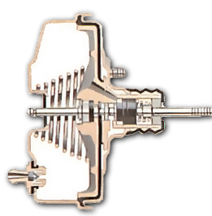](https://www.howacarworks.com/illustrations/how-the-brake-servo-works).

Figure 2: Brake off - both sides of the diaphragm are under vacuum

[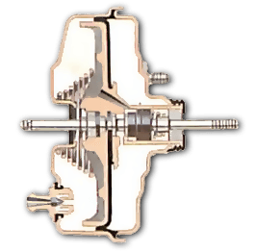](https://www.howacarworks.com/illustrations/how-the-brake-servo-works--2)

Figure 3: Applying the brake lets air in behind the diaphragm, forcing it against the cylinder.

## **Disc brake**

[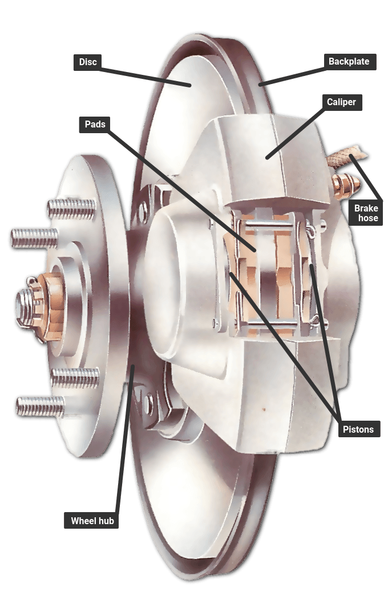](https://www.howacarworks.com/illustrations/disc-brake)

Figure 4: DISC BRAKE

* The basic type of disc brake, with a single pair of pistons. There may be more than one pair, or a single piston operating both pads, like a scissor mechanism, through different types of calipers - a swinging or a sliding caliper.
* A disc brake has a disc that turns with the wheel. The disc is straddled by a caliper, in which there are small hydraulic pistons worked by pressure from the master cylinder.
* The pistons press on friction pads that clamp against the disc from each side to slow or stop it. The pads are shaped to cover a broad sector of the disc.
* There may be more than a single pair of pistons, especially in dual-circuit brakes.
* The pistons move only a tiny distance to apply the brakes, and the pads barely clear the disc when the brakes are released. They have no return springs.

[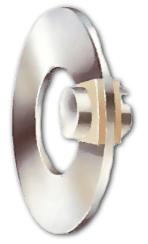](https://www.howacarworks.com/illustrations/disc-brakes--2)

Figure 5: SINGLE PISTON PAIR

* When the brake is applied, fluid pressure forces the pads against the disc. With the brake off, both pads barely clear the disc. Rubber sealing rings round the pistons are designed to let the pistons slip forward gradually as the pads wear down, so that the tiny gap remains constant and the brakes do not need adjustment.
* Many later cars have wear sensors leads embedded in the pads. When the pads are nearly worn out, the leads are exposed and short-circuited by the metal disc, illuminating a warning light on the instrument panel.

## **Drum brake**

[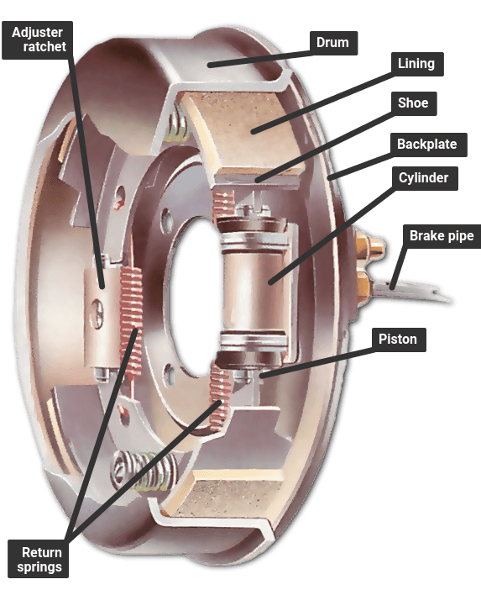](https://www.howacarworks.com/illustrations/drum-brake)

Figure 6: DRUM BRAKE

* A drum brake with a leading and a trailing shoe, which has only one hydraulic cylinder; brakes with two leading shoes have a cylinder for each shoe and are fitted to the front wheels on an all-drum system.
* A drum brake has a hollow drum that turns with the wheel. Its open back is covered by a stationary backplate on which there are two curved shoes carrying friction linings.
* The shoes are forced outwards by hydraulic pressure moving pistons in the brake's wheel cylinders, so pressing the linings against the inside of the drum to slow or stop it.

[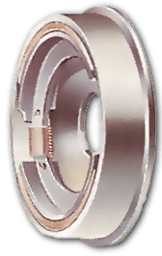](https://www.howacarworks.com/illustrations/drum-brakes)

Figure 7: DRUM

* With the brakes on, the shoes are forced against the drums by their piston. Each brake shoe has a pivot at one end and a piston at the other. A leading shoe has the piston at the leading edge relative to the direction in which the drum turns.
* The rotation of the drum tends to pull the leading shoe firmly against it when it makes contact, improving the braking effect.
* Some drums have twin leading shoes, each with its own hydraulic cylinder; others have one leading and one trailing shoe - with the pivot at the front. This design allows the two shoes to be forced apart from each other by a single cylinder with a piston in each end.
* It is simpler but less powerful than the two-leading-shoe system, and is usually restricted to rear brakes. In either type, return springs pull the shoes back a short way when the brakes are released.
* Shoe travel is kept as short as possible by an adjuster. Older systems have manual adjusters that need to be turned from time to time as the friction linings wear. Later brakes have [automatic](https://www.howacarworks.com/basics/how-automatic-gearboxes-work) adjustment by means of a ratchet.
* Drum brakes may fade if they are applied repeatedly within a short time - they heat up and lose their efficiency until they cool down again. Discs, with their more open construction, are much less prone to fading.

Reference: <https://www.howacarworks.com/basics/how-the-braking-system-works>

# ACTIVITY-2

## **Actuators**

* **Control Relay:** Relay that provides supply power to engine ECU and various actuators and fuel pump relay that drives fuel pump.
* **Fuel Pump:** Gives the fuel at the right pressure suitable for its work.
* **Injector:** It is an injection nozzle with solenoid that is controlled by ECM. Using intake air quantity and engine rpm, ECM calculates basic fuel injection time, and calculates corrective fuel injection period time on the basis of engine coolant temp, feedback signal from oxygen sensor during closed-loop-control
* **ISA (Idle Speed Actuator):** It is installed at throttle body of engine and control air intake rate into engine depending on ECU signal
* **Spark plugs:** This transmit electrical energy that turns fuel into working energy.
* **The Ignition coil:** This functions as an energy-storage device and transformer. It is supplied with DC voltage from the alternator, and provides the high tension ignition pulses for the spark plugs.

Reference: <http://www.micro-tronik.com/learning/technical-information/automotive/repair-basics/actuators/>

## **Types of sensors**

* **Temperature Sensors**/Detectors/Transducers are electronic devices that detect thermal parameters and provide signals to the inputs of control and display devices.
* **Proximity Sensors** are electronic devices used to detect the presence of nearby objects through non-contacting means.
* **Pressure Sensors**/Detectors/Transducers are electro-mechanical devices that detect forces per unit area in gases or liquids and provide signals to the inputs of control and display devices.
* **Photoelectric sensors** are electrical devices that sense objects passing within their field of detection, although they are also capable of detecting color, cleanliness, and location if needed.
* **Motion Sensors**/Detectors/Transducers are electronic devices that can sense the movement or stoppage of parts, people, etc. and supply signals to the inputs of control or display devices.
* **Level Sensors**/Detectors are electronic or electro-mechanical devices used for determining the height of gases, liquids, or solids in tanks or bins and providing signals to the inputs of control or display devices.

Reference:

<https://www.thomasnet.com/articles/instruments-controls/sensors/>

|  |  |  |
| --- | --- | --- |
| **Parameters** | **RTD (Resistive Temperature Detectors)** | **Thermocouple** |
| **Temperature range** | -200°C to 850°C | -100°C to 325°C |
| **Accuracy** | Best(0.1°C - 1°C) | Good(0.05°C - 1.5°C) |
| **Linearity** | Linear | Exponential |
| **Sensitivity** | 0.00385 ohm/ohm/°C (Platinum) | 10s of micro v /°C |
| **Response Time** | Slow(1s - 50s) | Fast(0.1s - 5s) |
| **Long Term Stability** | Best | Good |
| **Circuitry** | Complex | Simple to complex |
| **Typical size** | Bead diameter= 5 x wire diameter | 0.25 x 0.25 in |

# ACTIVITY-3

## **How BMC is applicable to transport**

The rapidly increasing demand for driving comfort and safety inevitably leads to the need for cutting-edge vehicle electrical system architecture. A comprehensive body control module system is aimed at communicating and integrating the work of all electronic modules through the vehicle bus. Strictly speaking, a BCM is an embedded system that controls load drivers and coordinates activation of auto electronics units.

The microcontrollers and connectors integrated into a BCM constitute the central structural unit of the system responsible for the controlling part. Operating data is transmitted to the control module through input devices. These may include sensors, vehicle performance indicators, and variable reactors.

After data is processed by the module, a response signal is generated through integrated output devices, including relays and solenoids. Through the system of output devices, the BCM coordinates the work of various electronics systems. This diagram of a body control module design shows a customized circuit that works as a gateway connecting and integrating smaller circuits.

## **Application of ECU’s**

An electronic control unit is a device responsible for overseeing, regulating and altering the operation of a car's electronic systems.

Each of a car's electronic features, such as an anti-lock braking system or electronic fuel injection setup, will typically be controlled by an ECU. Some systems may have their own ECU, while in other cases one ECU may be responsible for several associated systems.

The term ECU, however, is commonly used when referring to engine management systems - which are often called engine control units. These are responsible for controlling the injection and ignition system of an engine.

On a very basic level, an ECU is an electronic device fed with several inputs. The data from these inputs is assessed by the ECU and compared against stored on-board data. The ECU then decides what needs to happen to ensure the system in question functions properly and issues new commands to suit. These outputs then alter the operation of the system, delivering the desired effect.

For example, modern electronic fuel injection systems are controlled by ECUs. Data, including temperature, engine speed and accelerator position is fed into the ECU. The ECU then compares the data against on-board tables that tell it what the engine ideally needs, and alters the behavior of the fuel injectors - and in many cases the ignition system - to deliver the best performance.

On a very basic level, an ECU is an electronic device fed with several inputs. The data from these inputs is assessed by the ECU and compared against stored on-board data. The ECU then decides what needs to happen to ensure the system in question functions properly and issues new commands to suit. These outputs then alter the operation of the system, delivering the desired effect.

For example, modern electronic fuel injection systems are controlled by ECUs. Data, including temperature, engine speed and accelerator position is fed into the ECU. The ECU then compares the data against on-board tables that tell it what the engine ideally needs, and alters the behavior of the fuel injectors - and in many cases the ignition system - to deliver the best performance.

# ACTIVITY-4

## **Application of MBD in vehicle**

The model-based design methodology, computer-modeling techniques are used throughout the design process while the code is generated automatically when the model is already simulated and approved. Here are the stages of this process:

* The development team creates a conceptual design for a subsystem or component
* A mathematical model is created from a specification using graphical design and simulation tools, such as Matlab, Simulink, and Stateflow
* The model captures all the information about how the embedded system should run in a real vehicle (the component and its vehicle are modeled as one dynamic system)
* The mathematical model is used in all development stages including design, implementation, and validation
* The code is automatically generated based on the perfected model and incorporated into an embedded microprocessor

This way, the model-based design prioritizes the functionality of a component and assesses its integration into a larger system on each stage of the development, well before the physical prototype is created.

The model-based design has earned much popularity in the automotive industry quickly making traditional software development methodology outdated. This is due to the great benefits model-based design grants to automotive companies:

* **Increase in productivity**: All the phases are based on the same mathematical model; thus, there is no need to develop sketches, mock-ups, and prototypes and several models may be used for simulation without increasing the development time or cost.
* **Decreased development time and cost**: Model-based design is associated with rapid prototyping and validation of models and the automation of coding, which considerably speeds up the overall development process. Since testing is performed at each stage, the development team can avoid costly and risky product changes in the later stages.
* **Ability to introduce major changes late in the development process**: Block-oriented workflow and automatic code generation allow automotive engineers to correct erroneous specifications and replace large functional blocks even if the product is late into the development cycle.
* **Consistent documentation and implementation**: A model description becomes the basis for system documentation, substantially reducing the documentation cost and the associated errors. Since the model description is also the basis for actual code, documentation and implementation are kept consistent.
* **More reliable automotive systems**: The functionality of the system as a whole is a key focus from the very beginning of individual component development. In addition, extensive simulations, early testing, and automatic code generation eliminate the possibility of code errors and reduces the need for in-system debugging.
* **Simple reuse of the solutions**: The generated models can be reused in various applications and under various operating conditions. Simulation blocks and vehicle tests can be saved in a library and reused in the process of development of other models too.

# Activity 5

**Requirements for the subsystem**

|  |  |
| --- | --- |
| **Requirement ID** | **Description** |
| LR-01 | Ignition switch to power up the system |
| LR-02 | A knob to vary the speeds of the wiper |
| LR-03 | A display to give the speed in rpm |

**Test Plan**

**High Level**

|  |  |  |  |
| --- | --- | --- | --- |
| **TEST ID** | **DESCRIPTION** | **INPUT** | **OUTPUT** |
| HL_01 | Power up the system | Turn on the enable switch | Enable the System |
| HL_02 | Vary the speeds of wiper | Read the sensor values | Outputs the speed of the wiper |

**Low Level**

|  |  |  |  |
| --- | --- | --- | --- |
| **TEST ID** | **DESCRIPTION** | **INPUT** | **OUTPUT** |
| LL_01 | If the sensor reading is below 20, wiper shouldn’t move | Data <=20 | Speed of the wiper is 0 rpm |
| LL_02 | If the sensor reading is below 40, wiper should move with low speed | Data <= 40 | Speed of the wiper is 20rpm |
| LL_03 | If the sensor reading is below 60, wiper should move with medium speed | Data <= 60 | Speed of the wiper is 35rpm |
| LL_04 | If the sensor reading is above 60, wiper should move with high speed | Data > 60 | Speed of the wiper is 48rpm |